30.77: a) Using Kirchhoff’s Rules on the top and bottom branches of the circuit:
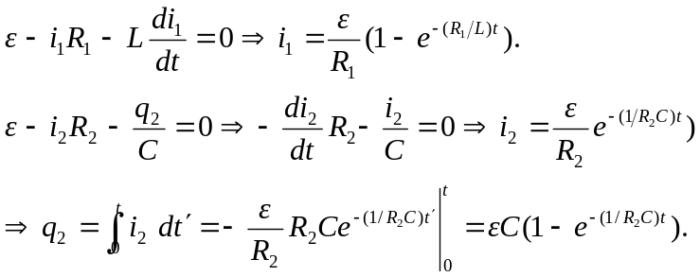

b) 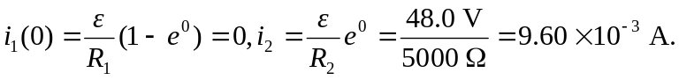
c) As 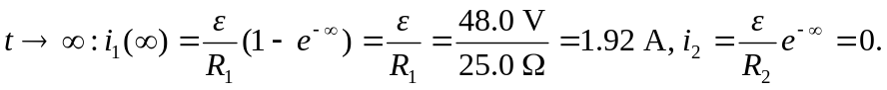
A good definition of a “long time” is many time constants later.
d) 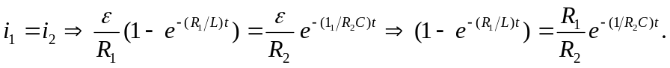
Expanding the exponentials like 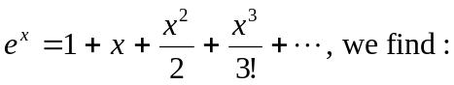
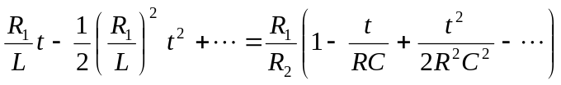

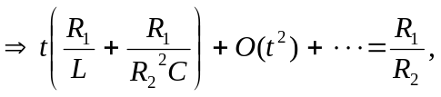 if we have assumed that 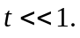 Therefore:
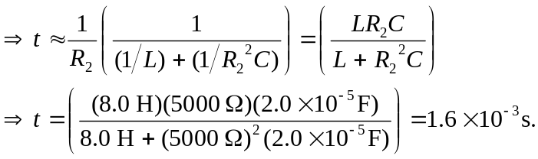

e) At
f) We want to know when the current is half its final value. We note that the current is very small to begin with, and just gets smaller, so we ignore it and find:
